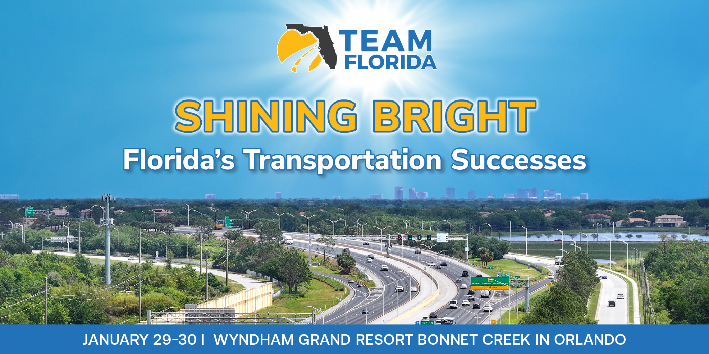

Draft Meeting Agenda

Thursday, January 29th

- 11 am – 1 pm – Board of Directors meeting and lunch

- 1:30 – 3 pm – Focus Sessions

    - Public Involvement
    - Talent Supply Chain – FDOT

- 3 – 3:30 pm – Networking Break

- 3:30 – 5 pm – Focus Sessions

    - Financial Issues – CFX
    - GEC Academy – FTE

- 5 – 7 pm – Networking Reception

Friday, January 30th

- 8 – 9 am – Networking Breakfast

- 9 – 11:30 am – General Session

  - Greeting by Doug Callaway

  - Opening Remarks by TEAMFlorida Chair & Lake County Commissioner Sean Parks

  - Welcome to Central Florida by TEAMFlorida Board Member & Osceola County Commissioner Brandon Arrington (invited)

  - Florida Turnpike Perspectives by Director Nicola Liquori

  - CFX Views by Executive Director Michelle Maikisch

  - Reason Foundation Presentation by Transportation Director Bob Poole

  - Texas Private Toll Road Presentation by SH-130 Executive Director Ananth Prasad

  - IBTTA Update by 2026 Chair Joi Taylor Dean

  - Keynote Address by USDOT Secretary Sean Duffy or FHWA Administrator Sean McMaster (invited)

  - Raffle of iPhone

- 11:30 am – 12:30 pm – Closing Luncheon with remarks by Florida High Tech Corridor CEO Paul Sohl, Rear Adm. USN (ret)

- 12:30 pm -- Adjourn

