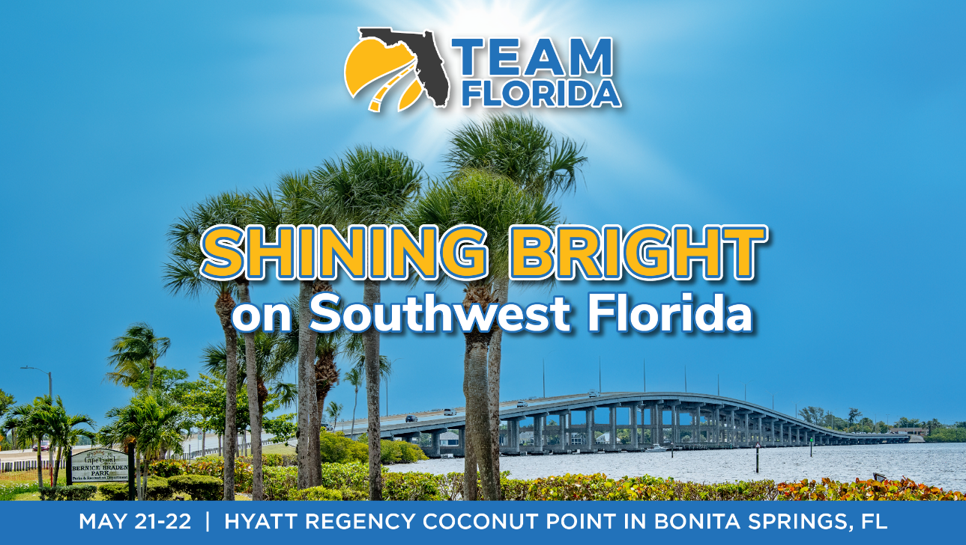

DRAFT MEETING AGENDA

Thursday, May 21st
11 am -1 pm Board of Directors meeting (Board members & invited guests only)
1:30 pm – 3 pm FOCUS SESSIONS
- MPO Advisory Council (MPOAC) Session
- FDOT District One Session (invited)
3 – 3:30 pm NETWORKING BREAK
3:30 – 5 pm FOCUS SESSIONS
- Lee County DOT/LeeWay – Interactive Transportation Session
- IT/Security Session hosted by THEA
5 – 7 pm NETWORKING RECEPTION

Friday, May 22nd
8 – 9 am NETWORKING BREAKFAST

9 – 11:30 am GENERAL SESSION
- Greeting – Doug Callaway, TEAMFlorida Exec. Dir.
- Opening Remarks – Rafael Garcia, GMX & 2026 TEAMFlorida Treasurer and Board of Directors member
- Welcome to Lee County – Commissioner Kevin Ruane (invited)
- Welcome to Southwest Florida – FTC Vice Chair David Genson
- Lee County DOT presentation – Robert Price, Lee County DOT
- FDOT District 1 presentation – Jamie Driggers, D-1 Sec (invited)
- Federal Update – Elaine Nessle, Exec. Dir. CAGTC (Coalition for America’s Gateways & Trade Corridors)
- Keynote Address – Special Surprise Invited Guest
- Thank you to Annual & Meeting Sponsors – Doug Callaway
- Welcome New Members – Maggie Bruno, EXP and 2026 TEAMFlorida Ambassador program Chair
- Raffle of New iPhone
11:30 – 11:40 am Brief Break to Get Food for Closing Lunch
11:40 am-12:25 pm CLOSING LUNCHEON
- Guest Speaker- Bobby Olszewski, former Florida Legislator, author and VP at TEAMFlorida member Global 5

12:30 pm ADJOURN

