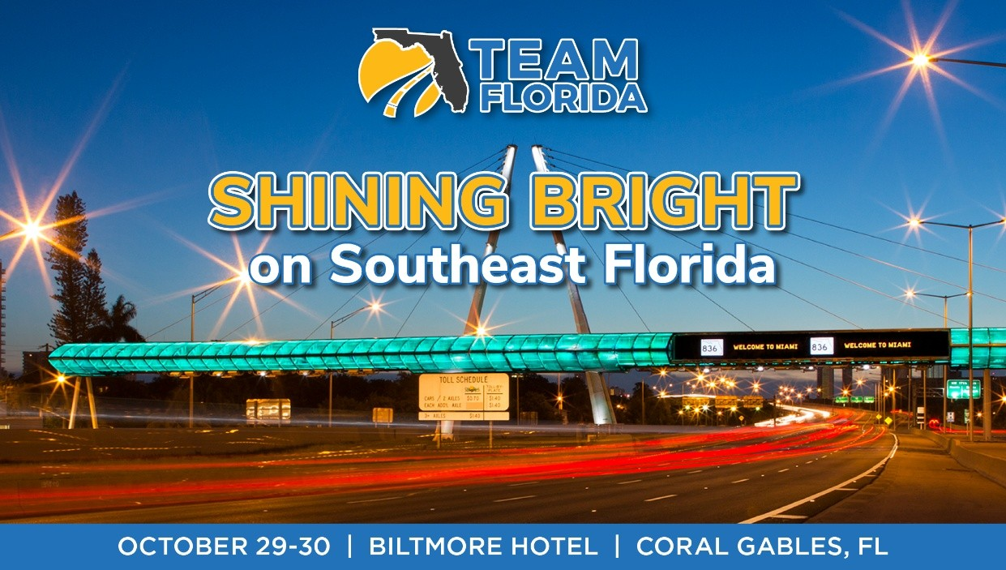

MEETING AGENDA

THURSDAY, OCTOBER 29th

11 am Board of Directors Meeting Brickell
(Board members & invited guests only)

Noon – Check-In

1:30 pm – 3 pm FOCUS SESSIONS

Focus Session – Funded, Approved, Stalled: The Workforce Crisis Danielson Gallery

Nobody Budgeted For
Presenter: Alyene G Calvo, EY
Brian Woods – Sr. Managing Director, EY Govt. People Consulting Leader
Janeth Merchan – Senior Manager

Focus Session – Ending Cost Estimate Creep: Why a Commercial Bowman

Framework Is the Missing Link Your Capital Program Needs

Presenter: Matthew Bezanson, Hill International

3 – 3:30 pm NETWORKING BREAK

3:30 – 5 pm FOCUS SESSIONS

Focus Session – Greater Miami Expressway Agency Danielson Gallery
Presenters:

Focus Session – Miami-Dade County Department of Transportation Bowman
& Public Works

Presenters:

5 – 7 pm NETWORKING RECEPTION CC Terrace

FRIDAY, OCTOBER 30th

8 - 9 am Networking Breakfast CC Terrace

9 am General Session CC Ballroom

- Greetings – Doug Callaway, TEAMFlorida Executive Director

- Welcome from the FTC Remarks – Commissioner Alex Lastra

- A Conversation with Governor Jeb Bush – facilitated by his three FDOT Secretaries,
Tom Barry, Jose Abreu, and Denver Stutler

- GMX Executive Director Rafael Garcia

- Joint FDOT D-4/D-6 Update by D-4 Secretary Steven Braun, P.E. and D-6 Secretary Daniel Iglesias, P.E.

- Miami-Dade County Department of Transportation & Public Works Director/CEO Stacy L. Miller, P.E.

- U.S. Senator Ashley Moody – video remarks

- Thank you to Annual & Meeting Sponsors – Doug Callaway

- Welcome New Members – Maggie Bruno, HBC Engineering and 2026 TEAMFlorida Ambassador program Chair

11:30 am Closing Luncheon CC Ballroom

- Speaker – Miami-Dade TPO Executive Director Aileen Bouclé

12:30 pm Adjourn

